1. Function Cohesion:

This method’s only function is let the system out print.

CheckOverdueBook Class

1. Temporal Cohesion:

Member functions are called at or near the same time.

Time Class

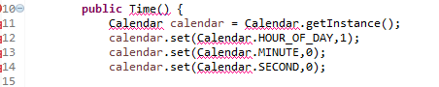

1. Type of Class Connascence:

If a class has an attribute of type A, it is tied to the type of the attribute. If the type of the attribute changes, the attribute declaration will have to change.

For example, if Stage class changes, LibrarianGUI class’s Stage() method changes.

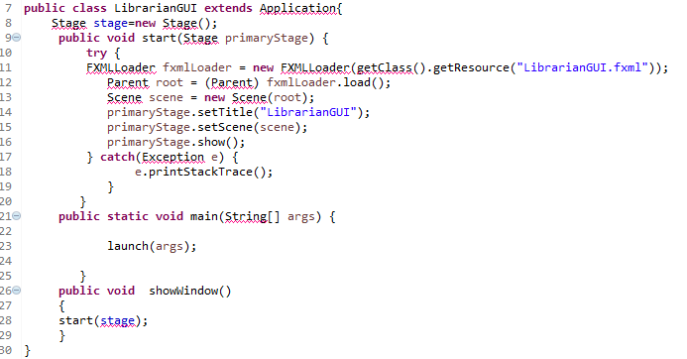

LibrarianGUI Class

1. Name Connascence:

If a method refers to an attribute, it is tied to the name of the attribute. If the attribute’s names changes, the content of the method will have to change.

Time Class

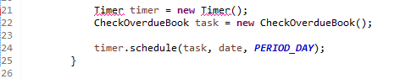

1. Convention connascence

If the range would change, then every method that used the attribute would have to be modified.

借書的判斷式(convention connascence)